**CPEG Automation Project sharing report**

Date: 7/4/2022 Time: 16:00 - 18:00 CN

1. CPEG By BU automation manpower saving goals and detail progress

- As of December 2021, the total manpower of CPEG DL1 is 19,238. In 2022, will save 1,631 persons, accounting for 8.5%.

- Up to June 4, automation of CPEG has saved 184 people, achieving 11% of the goal.

- The goal in April is to save 202 people. Currently, 4 people are saved, equivalent to 2%.

2. Kitting warehouse smart storage:

Procedure: Open - Scenario simulation - Kit Workstation Rationalizes - Warehouse Purchase - App Development - Online use - Close

Objectives:

- Import intelligent warehousing and ordering.

- Minimize inventory, prevent the risk of wrong material

- Cost down OP 14 people, 130,0000 RMB Profit, 17 months ROI.

System capabilities:

- Connecting between smart warehouse and smart ordering system, AGV intelligent control system and pushing information to mobile phones.

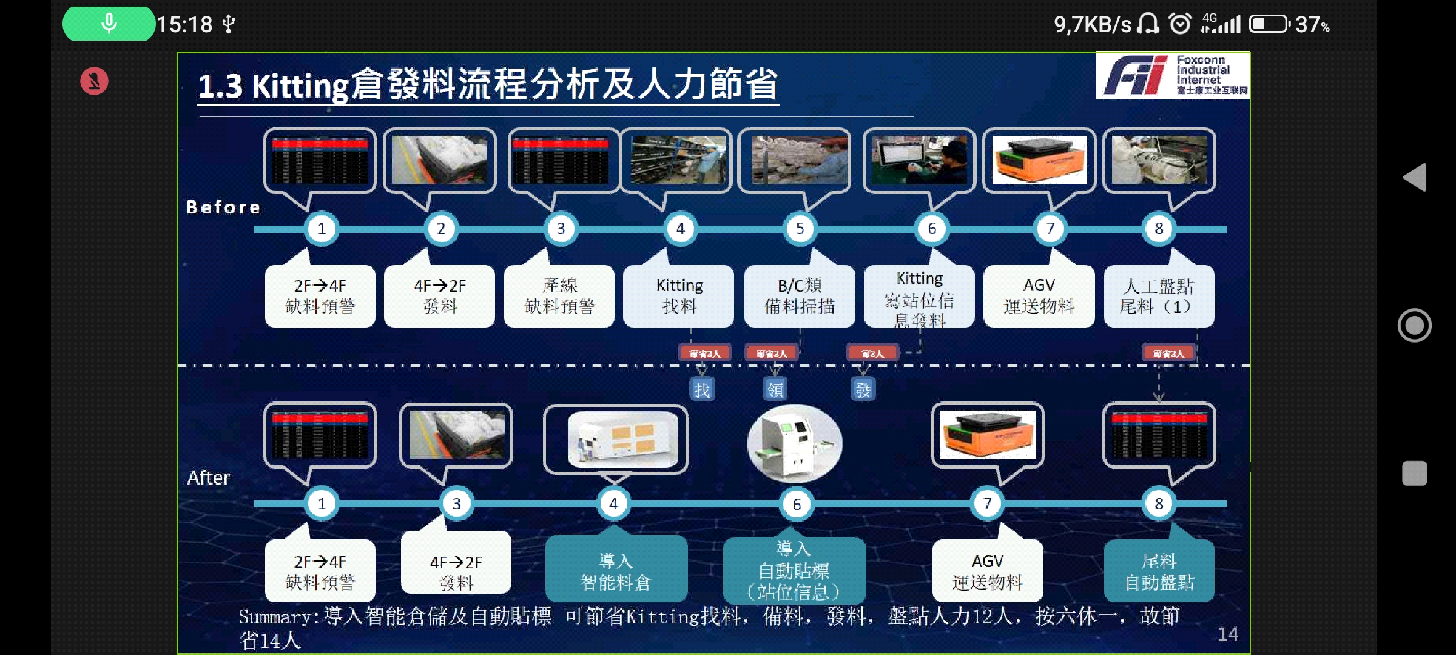

3. E360 automation line: Automatic welding system:

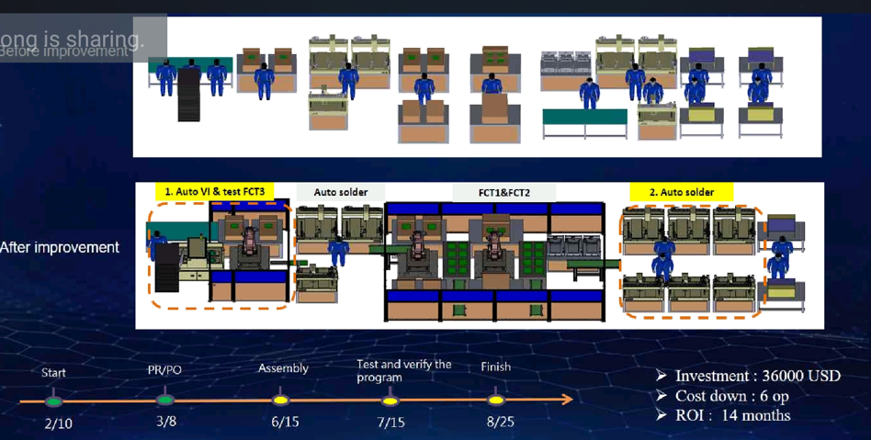

4. VI machine learning at PTH station:

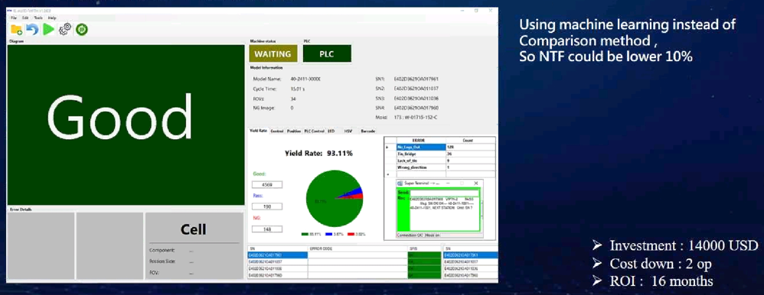

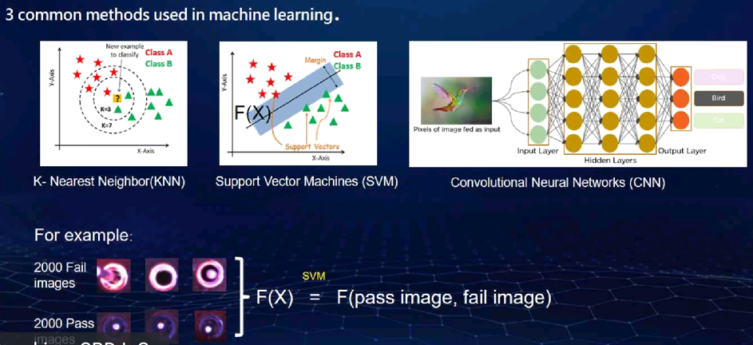

5. VI machine at packing station for Amman model:

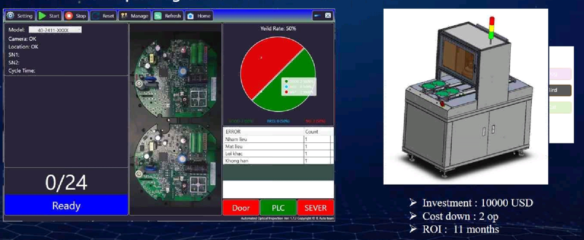

6. AOI projects:

Principles:

- Data collection: Take pictures with the image capturing system.

- Image processing: Apply different algorithms to improve image quality

- Feature extraction: Identify and quantify the main features of the image according to each preset region.

- Identification and control: Apply algorithms that compare the obtained data with a preset threshold to judge errors and make appropriate decisions.

- Connect to the SFIS system and transfer records to the system.

Software capabilities::

- The problems of lack of material, wrong material in the production line, abnormal quality

- Apply deep learning, detect and correct worker behavior

Application: Already applied in 5/7 projects

Improved work efficiency:

- 41% reduction in total test time

- 99% reduction risk of omission

- 90% reduction in training time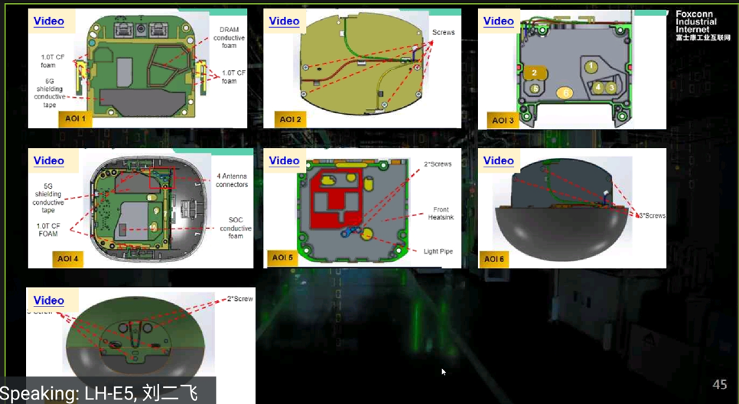

The most important goal of automation - intelligence projects is to save labor. For the Kitting project, by replacing the steps in the traditional process with a stage of automation - intelligence, the number of people cost down is 14. On the other hand, this system helps managers control more easily by sending information to mobile phones. With VI projects, since only fixed-position objects need to be detected in advance by operational engineers, only SVM is required. With AOI projects, applying deep learning algorithms helps improve work efficiency, especially can detect and adjust worker behavior to prevent errors.